Running your own Word Count Program
Grishma lamsal
2431171

Before completing the below tasks make sure that you have :

- Switched to the hadoop user.
- Navigated to the hadoop Sbin directory.
- Started the Hadoop Distributed File System (HDFS).
- Started the YARN Resource Manager.

If not refer to the below image to complete the above tasks :

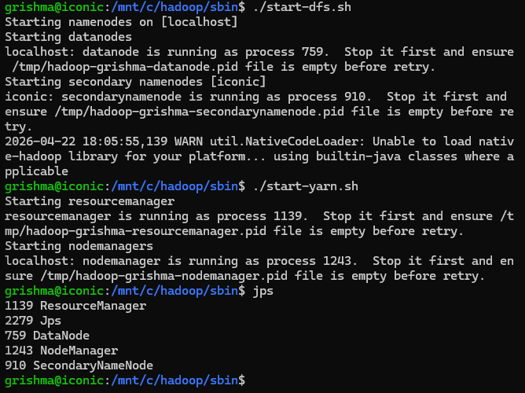
If jps (Java Processing Status) lists all the above running java processes, then you are good to go.

- Download WordCount.java file from the drive.

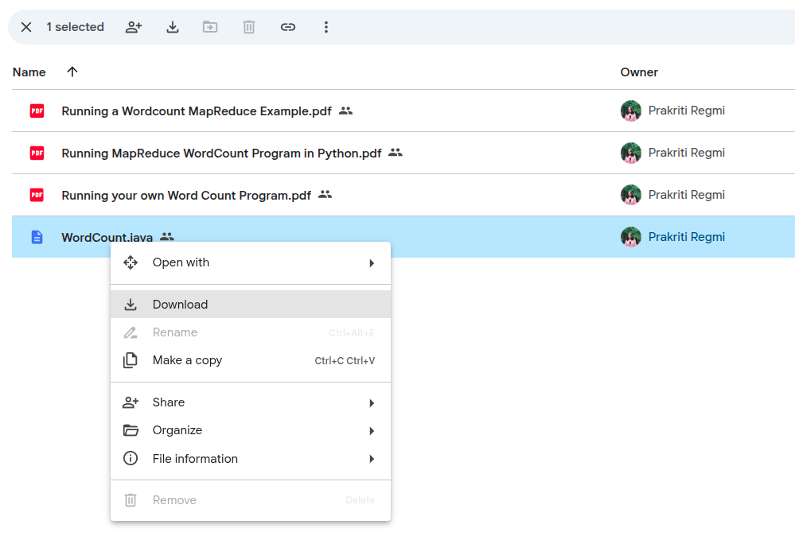
Note : Make sure that the java file you downloaded is in Downloads.

- In windows powershell type in the following command.

> echo $env:USERNAME

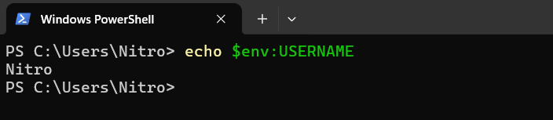

Take note of the output, mine is Nitro yours could be different.

- Move your WordCount.java file to your WSL home directory.

~$ cp /mnt/c/Users/YourUser/Downloads/WordCount.java ~/

Important: Don’t forget to replace “YourUser” with the output from the above step 2.

- Check if the WordCount.java file has been successfully copied to your WSL home directory.

~$ cd ~

~$ ls

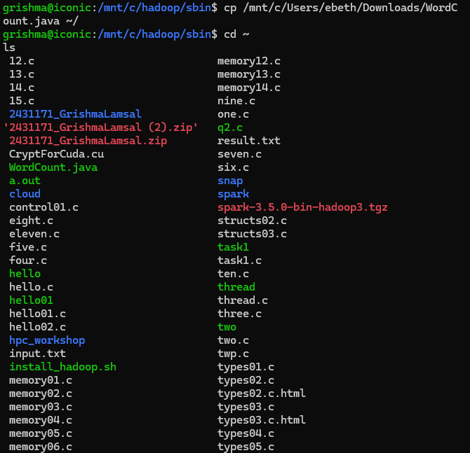l

- Compile the file :

~$ javac -classpath $(hadoop classpath) WordCount.java

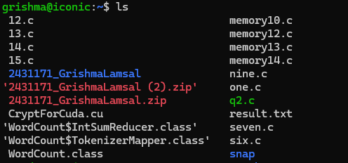

- Produce the Jar file :

~$ jar cf wordcount.jar Word*.class

- Create the input directory on the hdfs :

~$ hdfs dfs -mkdir /input_word

~$ hdfs dfs -ls /
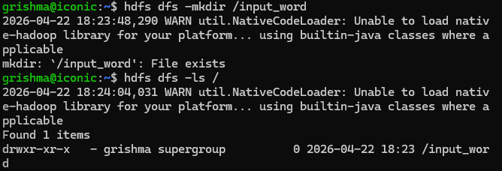
- Create the input files :

~$ echo A long time ago in a galaxy far far away > testfile1

~$ echo Another episode of Star Wars > testfile2
- Save the files to the input directory :

~$ hdfs dfs -put testfile? /input_word
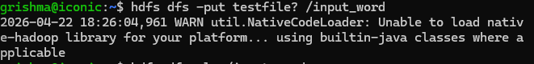
- Verify the uploads by checking if the files are inside the input_word directory.

~$ hdfs dfs -ls /input_word
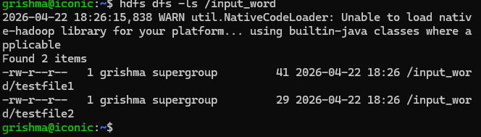
- It is important that the output directory does not already exist. If you have run the program before you need to delete the previous output directory :

~$ hdfs dfs -rm -R /output_word
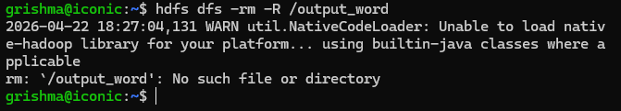
- Run the Map Reduce program :

~$ hadoop jar wordcount.jar WordCount /input_word /output_word
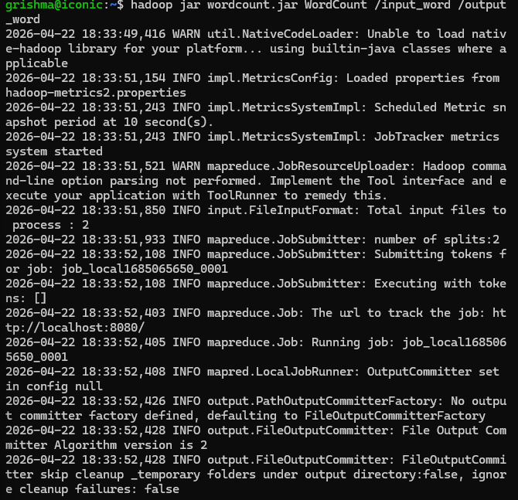
- Check what files are in the output directory :

~$ hdfs dfs -ls /output_word

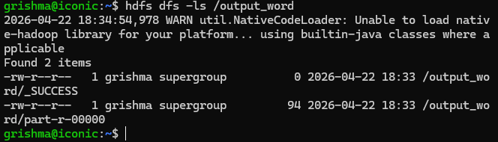

- See what is in the output file:

~$ hdfs dfs -cat /output_word/part-r-00000
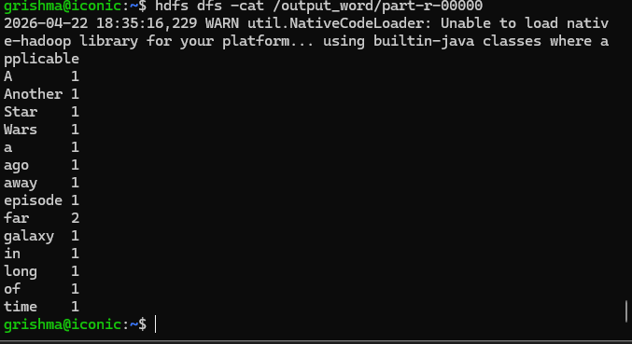

- If you want to use the output file outside the hdfs you have to retrieve it:

~$ hdfs dfs -get /output_word/part-r-00000 word-results.txt

